**Mahmudul Zahir**

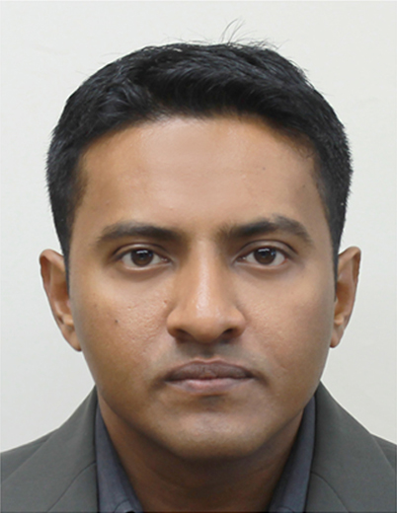

+61 469 129 996

[smmzahir@gmail.com](mailto:smmzahir@gmail.com)

7/69 Queen Victoria Street, Bexley, NSW – 2207

|  |
| --- |
| ***Key Skills*** |

* Able to work effectively with diverse groups of people
* Highly motivated & target oriented through communicative & managerial skill
* Perform well under pressure, Highly trainable & fast learner
* Attention to detail & Well organized
* Have extensive work experience in different team project
* Well developed verbal and written communication skills
* Highly energetic and responsible with great negotiation power

|  |
| --- |
| ***Tertiary Education*** |

**Masters of Business Administration (Maritime & Logistics Management)** *University of Tasmania*, *Australian Maritime College* **(Nov 2016)**

**Bachelor of Commerce (Accounting)** *University of Ballarat,* Australia

|  |
| --- |
| ***Vocational Education*** |

**Certificate III in Employment, Education and Training**. *OTEN-TAFE*, NSW (2011)

|  |
| --- |
| ***Customer Service/ Administrative Experience*** |

**Nov 2015 – Current**

**Border Force Officer, Department of Immigration and Border protection, (ABF)**

**Achievements:**

* Interviewing passengers for further progress.
* Collect, develop and evaluate the facts, evidence and significant data in assessing compliance without the violation of laws, rules or regulations.
* Redirect the information with integrity to the relevant division for further action.
* Processing GST claim under tourist refund scheme (TRS).
* Maintain the team work by fulfilling the departmental ad –hoc duties.

**Mar 2015 – Oct 2015**

**Food & Beverage attendant, Country Club Tasmania, (Federal Group Ltd)**

**Achievements:**

* Ensure excellent and professional client service at all times.
* Setup and reset specific Conference & Function activities as directed.
* Undertake general waiting and service duties of food and beverages.
* Maintain the team work to fulfill the estimated target by upholding the morale.
* Ensure security of cash and beverage stock on the premises and reconcile takings and stock as required.
* Maintain OHS issues and security procedures.

**Mar 2014 – Feb 2015**

**Sales Consultant, SYD Tax & Duty free**, **(Nuance Group, Sydney International Airport)**

**Achievements:**

* Contacts customers in person to offer and instruct them about the products.
* Assure outstanding guest relationships in luxurious retail environment (e.g. Technology, Alcohol, P & C, Clothing etc)
* Coordinate and manage daily business deals through maintain the budget reconciliation.
* Maintain the team work to fulfill the estimated daily target by upholding the morale.

**Sep 2013 – Feb 2014**

**Assistant Store Manager, Max Brenner (Sydney Central Park)**

**Achievements:**

* Supervise the bar attendant’s (Coffee & Food) and waiter’s for best customer service.
* Mentor new recruits to meet the daily targets and maintain the budget reconciliation.
* Assist area manager to supplier relation & administration.

**Oct 2012 – Sept 2013**

**Assistant Manager, King Street Brew House, (Sydney Darling Harbor)**

**Achievements:**

* Assure outstanding guest relationships through Client service.
* Supervise the bar attendant’s and waiter’s in surrounding areas.
* Appoint and guide new recruits in relevant areas.
* Assist in stock control, administration, cash reconciliation and other ad hoc duties.
* Collaborating subordinates and managers through effective communication.

|  |
| --- |
| ***Marketing Experience*** |

**May 2011 - Sept 2012**

**Sales Contractor, Salmat Pty Limited, Sydney**

**Achievements:**

* Contacts customers in person to offer and instruct them about the product & services.
* Work independently and harmoniously in a team environment.
* Perform under a challenging environment positively on day to day work.
* Committed to achieve the weekly sales target.

|  |
| --- |
| ***Accounting Experience/ Internship*** |

**Jan 2010 – Apr 2011**

**Junior Accounts Assistant, Acco-Tax Consultant, Sydney**

**Achievements:**

* Bookkeeping- Data entry to software’s and record keeping.
* Client interview- Prepare the client paper assessment.
* Prepare BAS- Account preparation with MYOB and prepare BAS.
* Prepare Individual TAX Return- Tax return using Handi tax software.

|  |
| --- |
| ***Stock Taking Experience*** |

**Team Member Stocktaking Retail (Casual-Mar 2012)RGIS Australia Pty Ltd, Sydney.**

**Team Member Stocktaking Retail (Casual- Mar 2012)** **Bunnings Warehouse,** (**Randwick, Artarmon)***.*

|  |
| --- |
| ***IT Expertise*** |

* Highly proficient on Microsoft office suites products.
* Proficiency on basic MYOB, Handi tax, HTML and Adobe Photoshop.

|  |
| --- |
| ***Linguistic Expertise*** |

* Bengali - Native.
* English - Fluent.
* Hindi Spoken – Basic Conversational.

|  |
| --- |
| ***Residential Status*** |

* Australian Citizen.

|  |
| --- |
| ***Interests*** |

* Languages- Mandarin, French.
* Horse Riding, Travel, Cricket, Video Gaming.

|  |
| --- |
| ***Professional Referees*** |

**Katherine Murray,** Senior Border Force Officer /Trainer, **Australian Border Force,**

Ph.: 0412 417 161. Email: **katherine.murray@border.gov.au**

**Rebecca Gatt,** Senior Border Force Officer Aviation (Travellers), **Australian Border Force,**

M: 0423 007 220. Email: [rebecca.gatt@border.gov.au](mailto:rebecca.gatt@border.gov.au)

|  |
| --- |
| ***Academic/ Professional Referees*** |

**A/Professor Marcus Bowles,** (University Lecturer), Director Institute for Working Futures, lead researcher Digital Economy & Regional Futures industry project, **AMC, University of Tasmania**

Ph.: +61 412 439 009. Email: **marc.bowles@utas.edu.au**, **mbowles@workingfutures.com.au**